  - 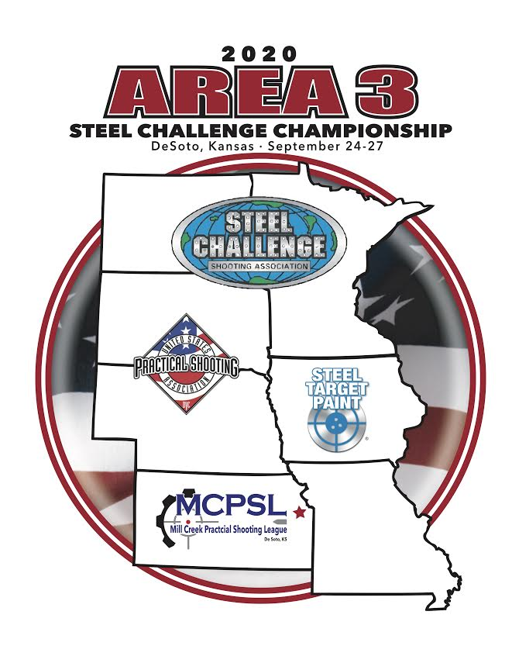
  - Hosted by Mill Creek Practical Shooting League
  - Desoto, Kansas
2020 Area 3 Championship
Presented by Steel Target Paint
USPSA Steel Challenge

USPSA level 3 steel challenge match (approved), 8 Stages 195 rounds minimum

Date – Four day match Thursday, September 24th through Sunday, September 27th.

Location – Mill Creek Rifle Club
7215 Gardner Rd
Desoto, KS 66018

Match Director – Ben DeHaemers dehaemers002@gmail.com
Range Master – TBD

Registration: https://practiscore.com/2020-steel-target-paint-area-3-steel-challenge-championship/register

Sponsors – Thank you to our match sponsors, please check out their websites below.

Title Sponsor – Steel Target Paint

Supporting Sponsors – CWA accessories, HD Hunters Gold, Striplin gunworks, Stonebridge gunworks

Parking and Motorized Vehicles – Competitor vehicles are restricted to the designated parking areas. The designated parking area is the gravel parking lot inside the main gate, and the grass area between the parking lot and high-power berm. See range match for details. No competitor vehicles may be parked directly in front of bays. Small vehicles may be used on gravel surfaces for transport between bays with Match Director Approval only.

Scores – Scoring of the match will be done utilizing PractiScore and will be available shortly after
completion of the match. We use a closed network system. Syncing of scores to your personal device
will not be permitted during the match. Each competitor will physically approve their stage score on the scoring tablet. It is strongly advised that each competitor check the accuracy of their scores
with the scoring RO.

Check In - Competitors need to check in prior to the start of the match. Check in is available inside the club house Thursday Sept 24th from 10am to 1pm, Friday 25th from 6am to 7:30am and 11pm to 1pm, Saturday Sept 26th from 6am to 7:30am and 11pm to 1pm, and Sunday Sept 27th from 6AM to 7:30am.

Shooter’s Meeting – There will be no shooters meetings prior to match start times. Competitors should report directly to your squad and check in with the stage RO in time to be ready to shoot at match start time.

RO/Staff Shoot - RO’s and staff will shoot the match prior to the match and within the regularly scheduled match. Please make arrangements directly with the match director to accommodate your match schedule.

Squadding - 8 squads of 11 competitors each per each flight. There will be no breaks in the
flights. Squadding is by self-squadding on Practiscore or with direct interaction with the match director.

Changing Divisions - If you need to change divisions, you must let the statistician know at check in.
We will run the classification update from USPSA on August 24th.

Awards – Division, class and category winners will be announced after completion of Sunday am flight and arbitration.

Awards will be given out per USPSA Steel Challenge guidelines.

Food – Lunch will be included on Thursday, Friday, and Saturday. Current Menu is anticipated to be catered BBQ.

T-Shirts – T-Shirts are currently being developed. More news very soon.

Prize Drawing – Our sponsors have donated prizes. Competitors will be able to pick from one of three colored prize tables ranging in item worth designated by random coinciding colored chips in the registration bags. Each competitor will have one colored chip for use at a prize table during the match.

Match Briefing

Rules: This match will be run under the latest edition of the USPSA Steel Challenge Rulebook.

Entering the Course of Fire: Competitors are free to enter the competition area when the match is not active. Please to not move or otherwise interfere with any match equipment. During active flights, competitors not active in the shooting squad, should apply respect for the competitors with appropriate distance and noise level.

DQ Policy: In the unfortunate event a competitor is disqualified from the match, the range master will be contacted and made present to interact with the competitor. In the event the range master is not available, the match director will be contacted.

Eye and Ear Protection: All competitors must wear eye and ear protection while on the line or on the
range while shooting is taking place. Eye protection MUST be worn at all times by everyone on the range. Please make extra considerations for any children that may be at the range with appropriate eye and ear protection.

Spectators: If you have friends or family coming to watch the match, they are required to have
appropriate eye and ear protection. Any children are the responsibility of the parent and are not
allowed to run around unsupervised.

Cold Range: This match is a cold range. Firearms may only be handled in safety areas or under the
supervision of an RO. Competitors arriving with a loaded firearm are required to contact a match official for escort to an unloading area. Bays and berms not part of the match are not to be used for handling firearms, including for loading/unloading, except under the supervision of a Mill Creek Rifle Club member.

Safety Areas: Marked safety areas are located around the range for dry fire practice and gun repair, etc.
No ammunition may be handled in any safe area. Competitors are required to be entirely within the marked safe area boundaries when handling firearms.

Painting Steel: Competitors are expected to stay together as a squad, paint steel targets between competitors, and help maintain efficiency on each stage.

Inspection: When the entire squad is assembled, a brief stage walkthrough will be given, followed by a
five-minute inspection and question period.

Tear-Down: Tear down will occur after the awards ceremony. Any help is GREATLY appreciated. Each stage has its own utility cart for the stage equipment to easily fit into. Just dismantling the stage and getting it into the cart is a HUGE help. We can come by with an ATV and pull the carts to their

Lost Brass: This is a lost brass match.

Scheduling: All stages will be shot in order. There will be no skipping stages by any squad unless directed by Match Director or Range Master.

Arbitrations: Arbitrations are initiated with the presentation of a $100 cash fee and the completed
arbitration form delivered to the Range Master. Forms are available from the match director or
statistician.

Squad Matrix: We have 8 squads starting on each of the 8 bays. All shooters will start at
8 am for morning flights and 1:30pm for afternoon flights and progress through the stages in order unless otherwise directed by the Match Director or Range Master.

Stage Layout:

25m Bay: Pendulum
Pizza Range: 5 To Go
Range 1: Accelerator
Range 2: Outer Limits
Range 3: Showdown
Range 4: Speed Option
Range 5a: Roundabout
Range 5b: Smoke and Hope

Maps of the range and bays are below.

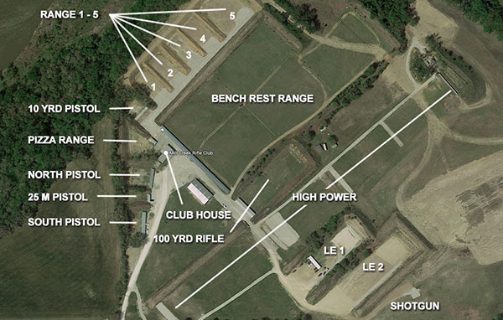
Sponsors

Steel Target Paint:
https://www.rangestore.net/

CWA:
https://www.cwaccessories.com/

HuntersGoldHD:
https://huntershdgold.com/

Striplin Custom Gunworks:
https://striplincustom.com/

Shooting Solutions LLC:
https://shootingsolutionsllc.com/

Stonbridge Gunworks:
https://www.stonebridgegunworks.com/

Michelle Woitzel Graphic Arts
https://www.woitzelphotography.com/

MORE COMING!

